|  |  |  |  |  |  |
| --- | --- | --- | --- | --- | --- |
| |  |  |  | | --- | --- | --- | | **المــمـــــــــلكــــة العـربية الســــــعودية**  **بــينبع الـــــــهـــــــــــيـــــئة الملــــــكـــــــية**  **قــــطـــاع الـكــــــــــــلــيات والـمــعــاهـد** | Description: YUC | **Kingdom of Saudi Arabia**  **Royal Commission at Yanbu**  **Colleges & Institutes Division** | | **كـــــلية ينبع الجــــــــــــــــامـــــــــــعية**  **قسم علوم وهندسة الحاسب الألي**  **قسم تقنية المعلومات والحاسب الآلي** | **Yanbu University College**  **Computer Science & Engineering Dept.**  **Information & Computer Technology Dept.** |   LAB 10 |
| **ACADEMIC YEAR**  1442/1443 H(2021/2022 G)**,** SEMESTER II (212) |

|  |
| --- |
| **Object oriented web development**  CS 382 |

|  |  |  |  |
| --- | --- | --- | --- |
| **STUDENT NAME:** |  | | |
| **STUDENT ID:** |  | **SECTION:** | 1 |

|  |  |
| --- | --- |
| **FOR INSTRUCTOR USE ONLY** | **GENERAL INSTRUCTIONS** |

|  |  |  |  |  |
| --- | --- | --- | --- | --- |
| **Q. No.** | **CLOs** | **MAX MARK** | **MARKS OBTAINED** | * Write your name and I.D. number in the space provided above. |
| **1-5** | **2.01** |  |  |
| **TOTAL MARKS** | |  |  |

|  |  |
| --- | --- |
| **MARKED BY: Dr.Kajal Nusratullah** | **Signature:** |

# AUTHORIZATION AND AUTHENTICATION

# Objective:

This lab is designed to understand and hands on the concept of Authentication and Authorization.

**Lab Exercise:**

**The Html code for the following form is posted for your aid on Blackboard.**

## *Login Page to authorize user*

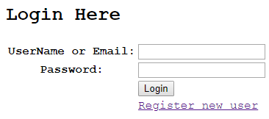

## *Registration Page to authenticate user*

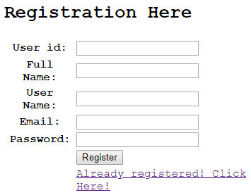

**Perform the following task.**

1. **Create a table with the given structure in Php My Admin.**

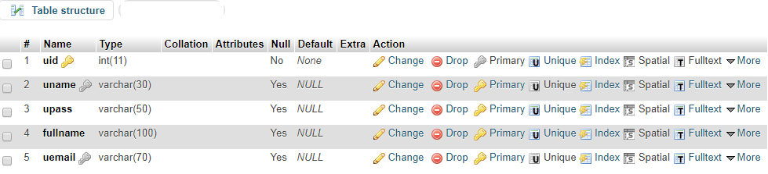

1. **Reuse the previous connection class in order to create the connection.**
2. **Create two function name chk_login and reg_user on the basis of following psuedocode.**

/*** for registration process ***/

public function

reg_user($uid,$name,$username,$password,$email){

$sql="SELECT * FROM users WHERE uname='$username'

OR uemail='$email'";

//checking if the username or email is available in conn

$check = $this->conn->query($sql) ;

$count_row = $check->num_rows;

//if the username is not in db then insert to the table

if ($count_row == 0){

$sql1="INSERT INTO users

(uid,uname,upass,fullname,uemail)VALUES

('$uid','$username', '$password', '$name',

'$email')";

$result = mysqli_query($this->conn,$sql1) or

die(mysqli_connect_errno()."Data cannot inserted");

return $result;

}

else { return false;}

}

/*** for login process ***/

public function

chk_login($emailusername,$password){

//$password = md5($password);

$sql2="SELECT uid from users WHERE

uemail='$emailusername' or uname='$emailusername'

and upass='$password'";

//checking if the username is available in the table

$result = mysqli_query($this->conn,$sql2);

$user_data = mysqli_fetch_array($result);

$count_row = $result->num_rows;

if ($count_row == 1) {

return true;

}

else{ return false;}

}

}

?>

1. **Create the php file named registration.php in order to process the registration form.**

<?php

include 'user.php';

$user = new User(); // Checking for user logged in or not

if (isset($_REQUEST['submit'])){

extract($_REQUEST);

$register = $user->reg_user($uid,$fullname, $uname,$upass, $uemail);

if ($register) {

// Registration Success

echo 'Registration successful

<a href="login.html">Click here</a> to login';

} else {

// Registration Failed

echo 'Registration failed. Email or Username already exists please try again';

}} ?>

1. **Create the php file named login.php in order to process the login form.**

<?php

include 'user.php';

$user = new User();

if (isset($_REQUEST['submit'])) {

extract($_REQUEST);

$login = $user->check_login($emailusername,$password);

if ($login) {

// Registration Success

header("location:home.php");

} else {

// Registration Failed

echo 'Wrong username or password'; } } ?>

Here the $_REQUEST is an associative array that by default contains the contents of $_GET, $_POST and $_COOKIE.

This function uses array keys as variable names and values as variable values. For each element it will create a variable in the current symbol table.

The extract($_REQUEST) function imports variables into the local symbol table from $_REQUEST.

In the case of this code it will retrieve the status of submit button. This function returns the number of variables extracted on success.

Redirection from one page to another in PHP is commonly achieved using the following two ways:

Using Header Function in PHP:

The header() function is an inbuilt function in PHP which is used to send the raw HTTP (Hyper Text Transfer Protocol) header to the client.